**PRIMARY REVIEWER**

**Proposal: ______________**

**Please use the diagram below to provide 6 numerical scores for each proposal (SEE GUIDE BELOW)**

|  |  |
| --- | --- |
| **Criteria** | **Score (1-9)** |
| **Feasibility** |  |
| **Clarity of Abstract, Rationale and Impact** |  |
| **Clarity of Procedure** |  |
| **Credibility- quality of references** |  |
| **Relevance** |  |
| **Innovation/creativity** |  |
| **Average of scores above (add the scores and divide by 6)** |  |

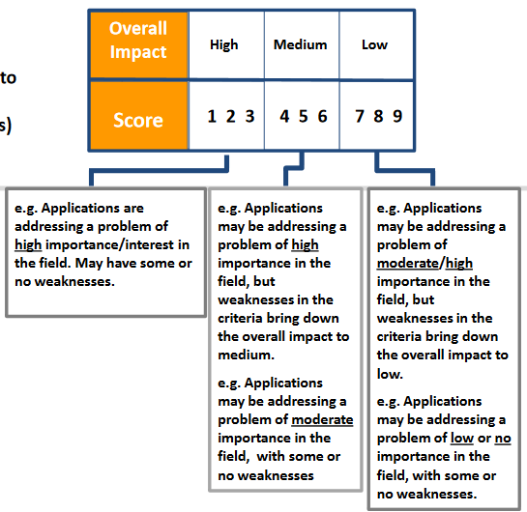

**AS PRIMARY REVIEWER: Evaluate the proposal for the following 4 areas. PROVIDE IN-DEPTH WRITTEN CRITICISM ADDRESSING EACH SECTION.**

**Proposal:_________________**

**Significance:** Does the project address an important problem or a critical barrier to progress in the field? Is there a strong scientific premise for the project? If the aims of the project are achieved, how will scientific knowledge, technical capability, and/or clinical practice be improved? How will successful completion of the aims change the concepts, methods, technologies, treatments, services, or preventative interventions that drive this field?

**Innovation:** Does the application challenge and seek to shift current research or clinical practice paradigms by utilizing novel theoretical concepts, approaches or methodologies, instrumentation, or interventions? Are the concepts, approaches or methodologies, instrumentation, or interventions novel to one field of research or novel in a broad sense? Is a refinement, improvement, or new application of theoretical concepts, approaches or methodologies, instrumentation, or interventions proposed?

**Approach:** Are the overall strategy, methodology, and analyses well-reasoned and appropriate to accomplish the specific aims of the project? Have the investigators presented strategies to ensure a robust and unbiased approach, as appropriate for the work proposed? Are potential problems, alternative strategies, and benchmarks for success presented? If the project is in the early stages of development, will the strategy establish feasibility and will particularly risky aspects be managed? Have the investigators presented adequate plans to address relevant biological variables, such as sex, for studies in vertebrate animals or human subjects?